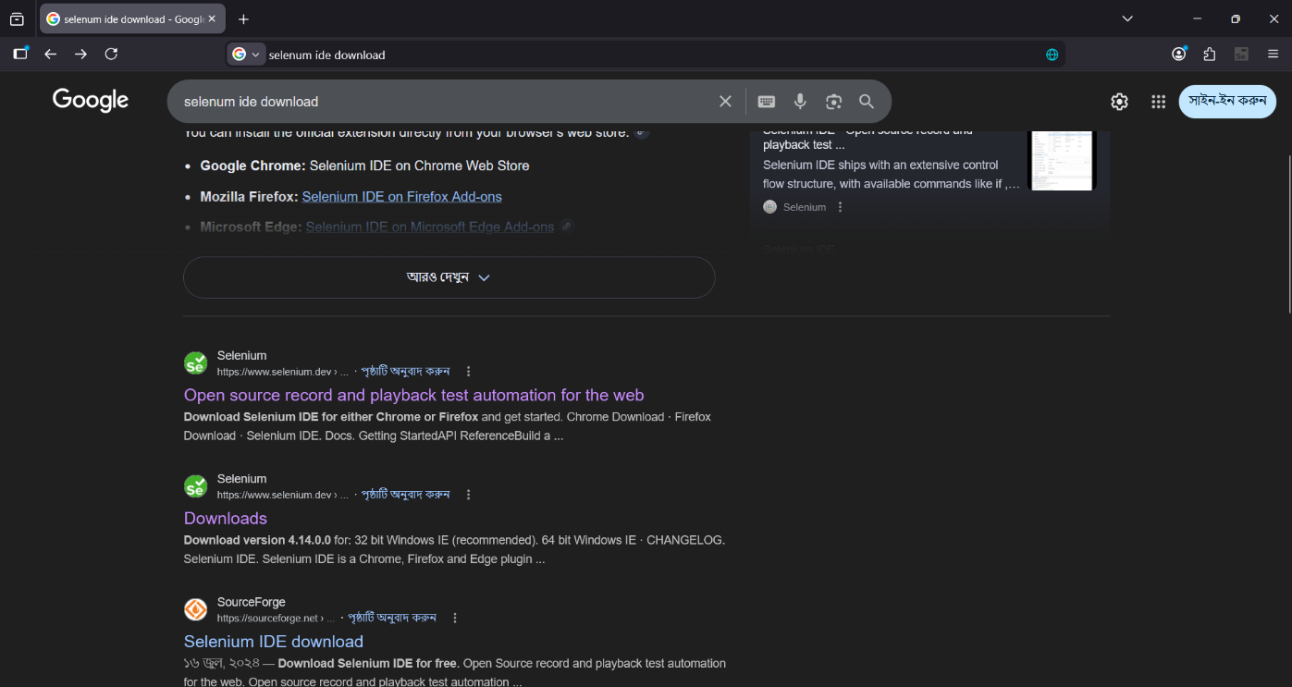
Step – 1
Website
Search Selenium IDE

Step – 2
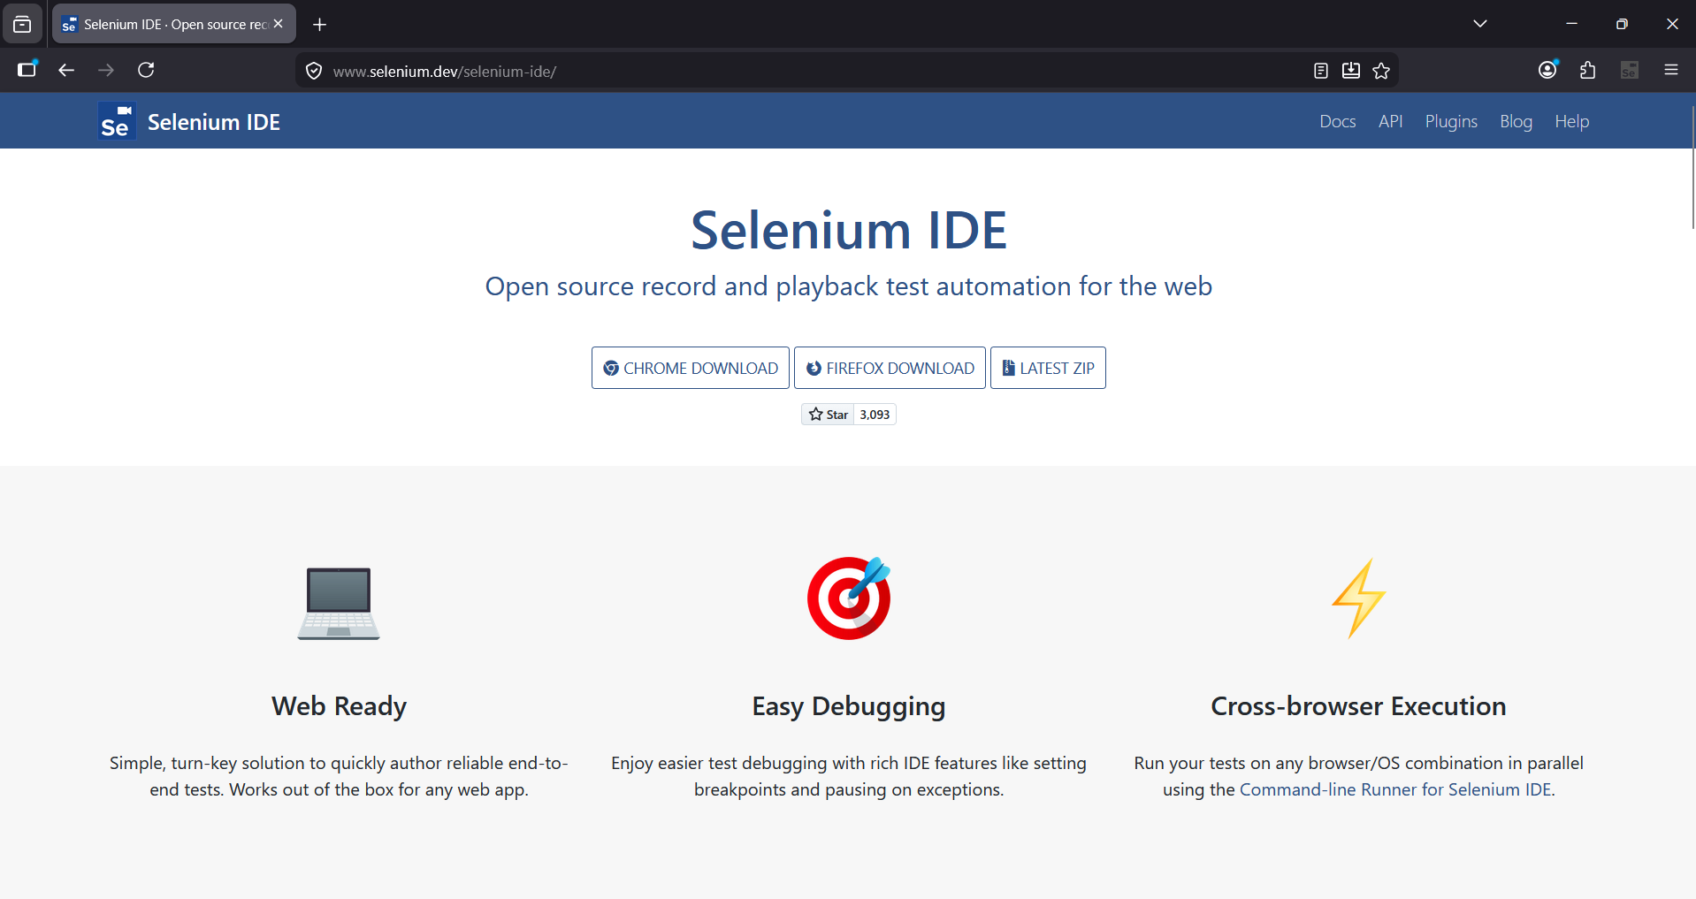
Download in FIREFOX

Step – 3
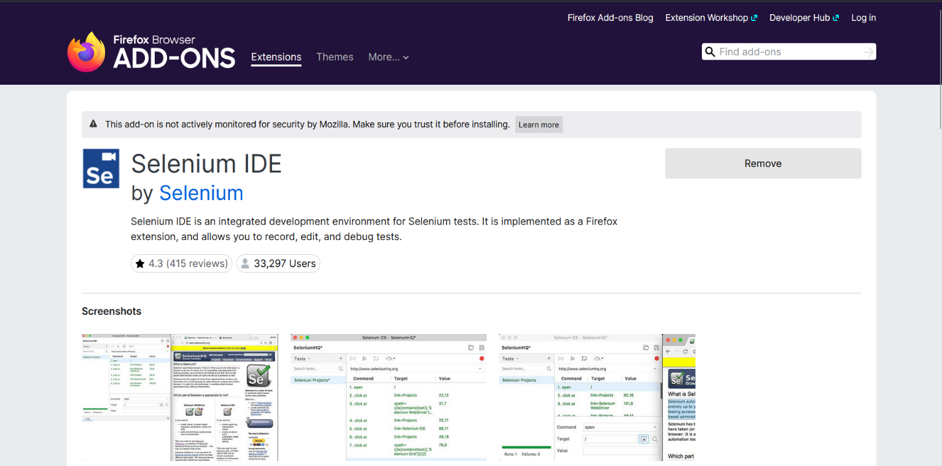
Add Selenium IDE extension
Step – 4
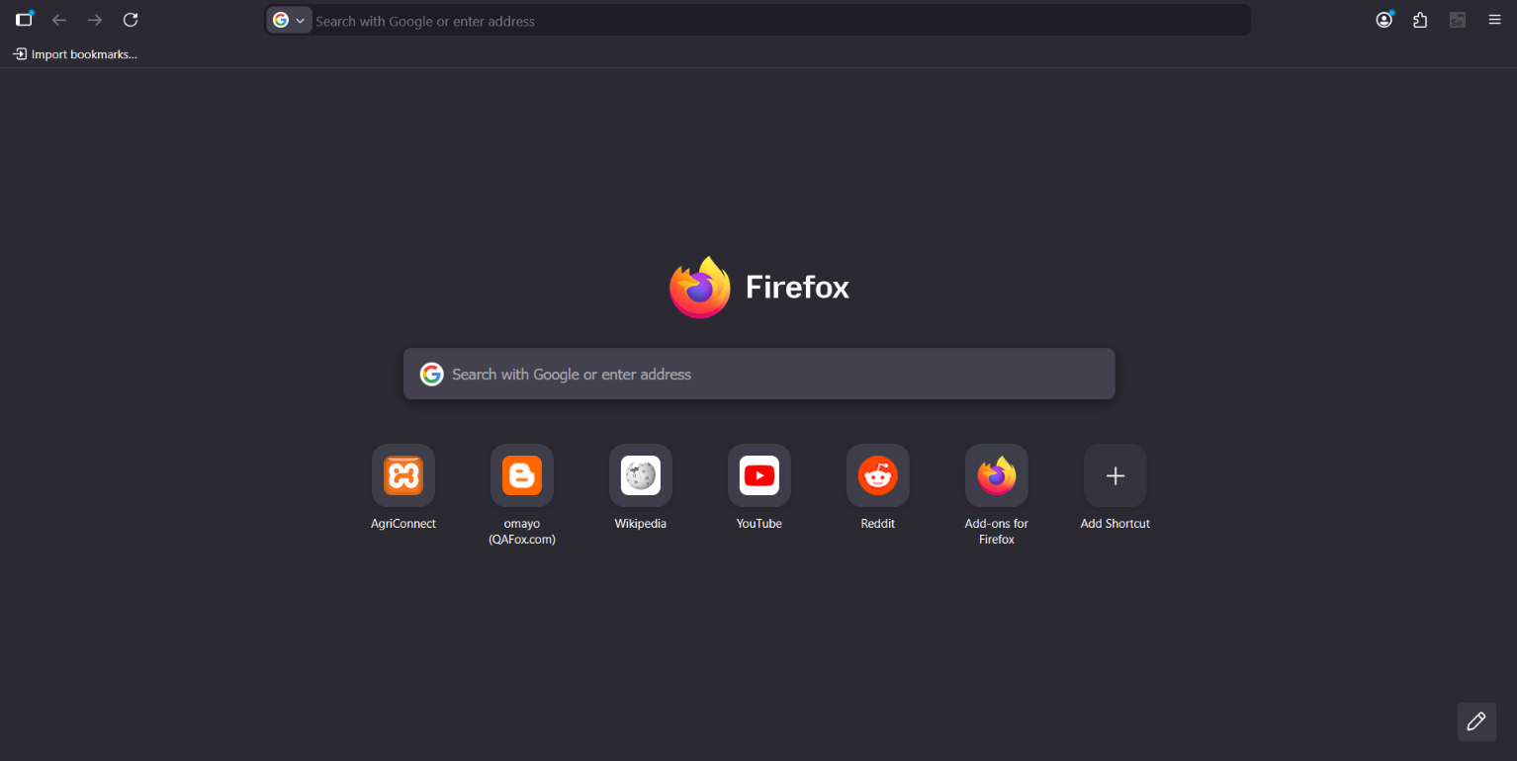
IDE Extension added,
Click to start

Step – 5
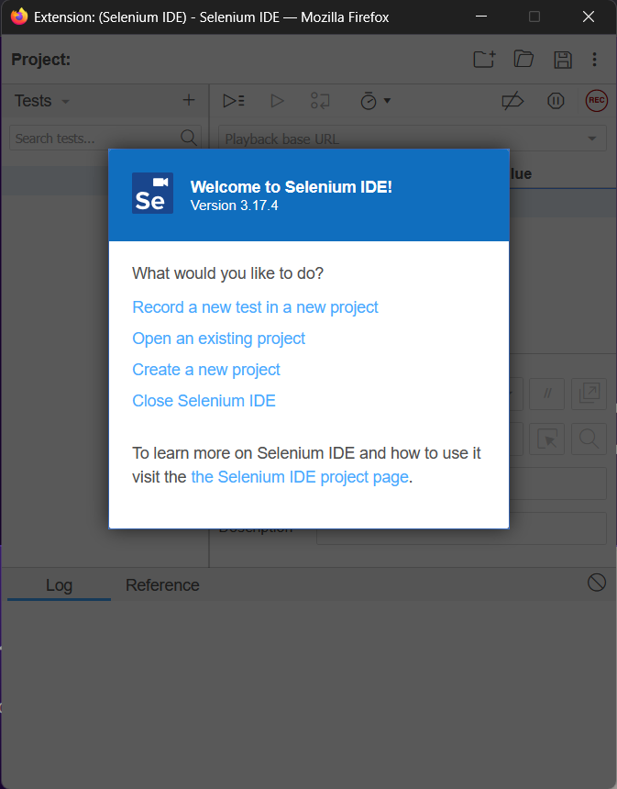
Create a project for testing

Step – 6
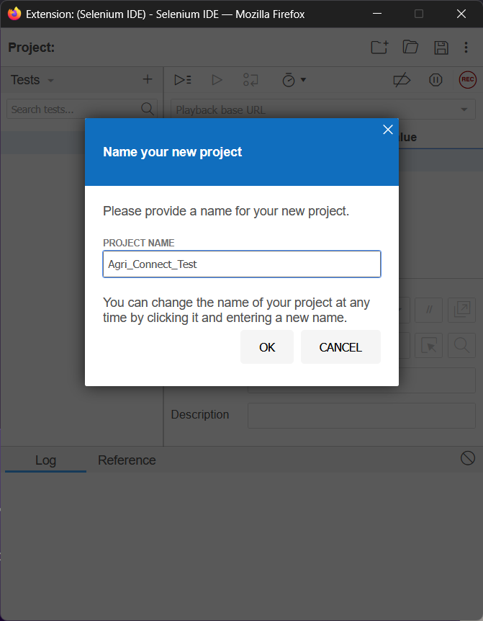
Set a name for the project

Step – 7
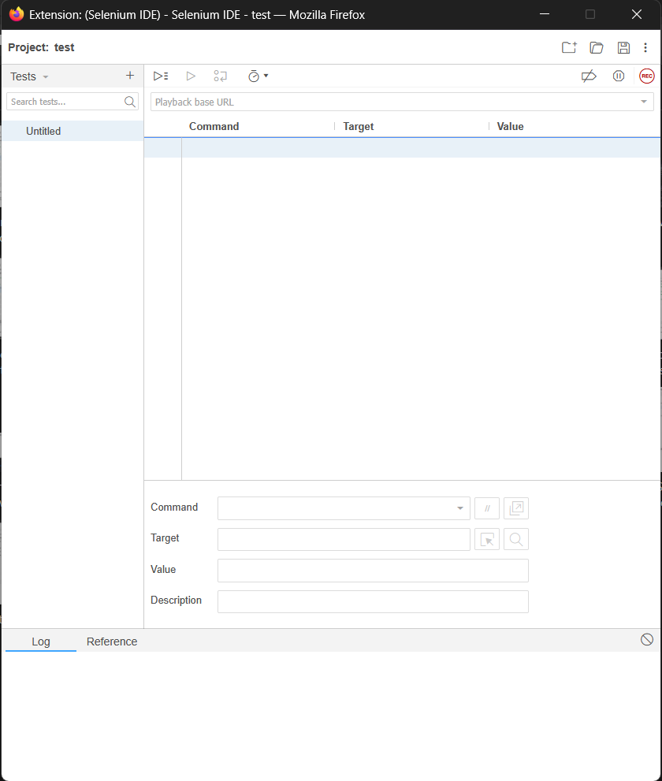
*Blank (initial interface) interface of Selenium IDE

Step – 8

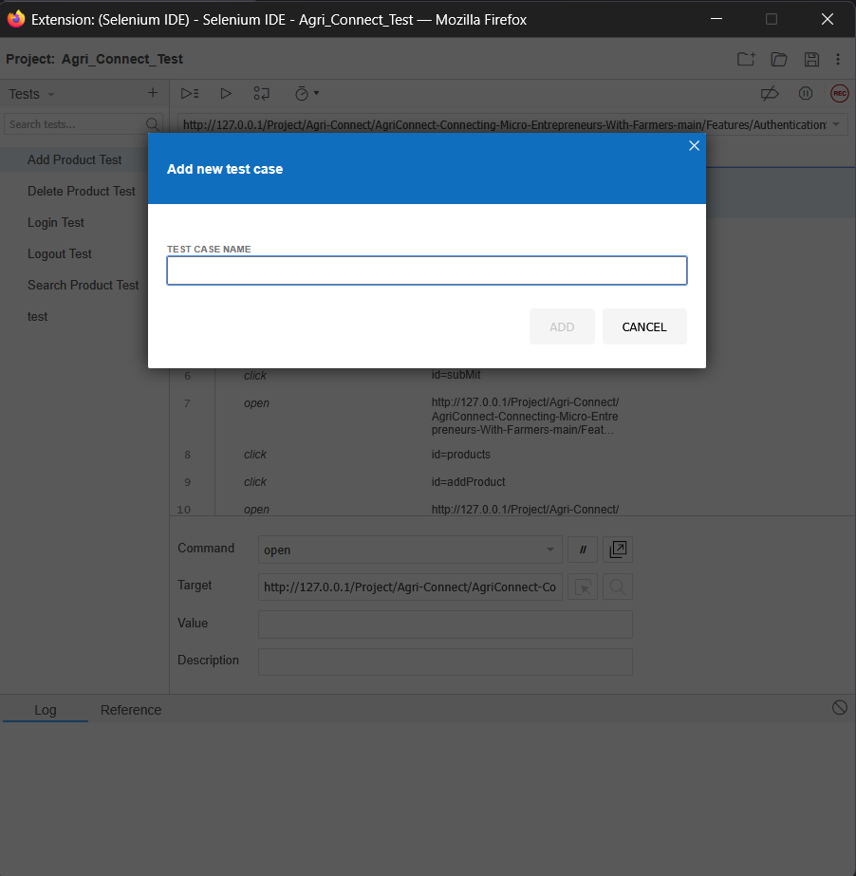
*Add new test case with a test name

Step – 9
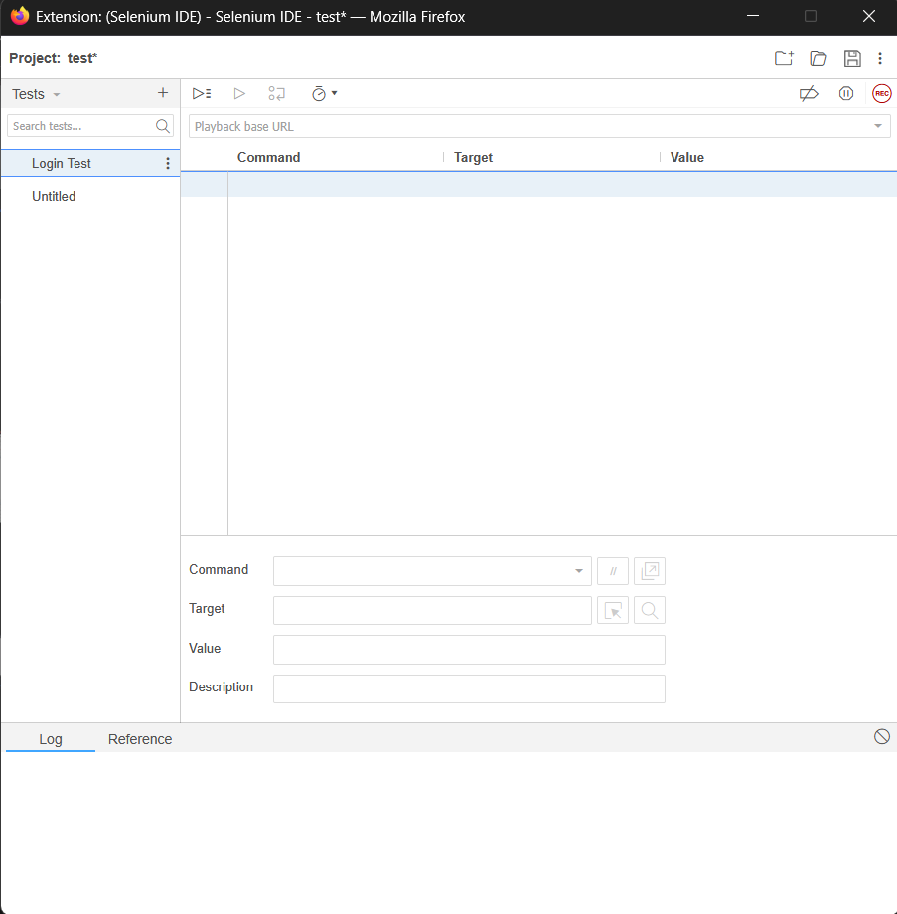

*A new test added.

Step – 10
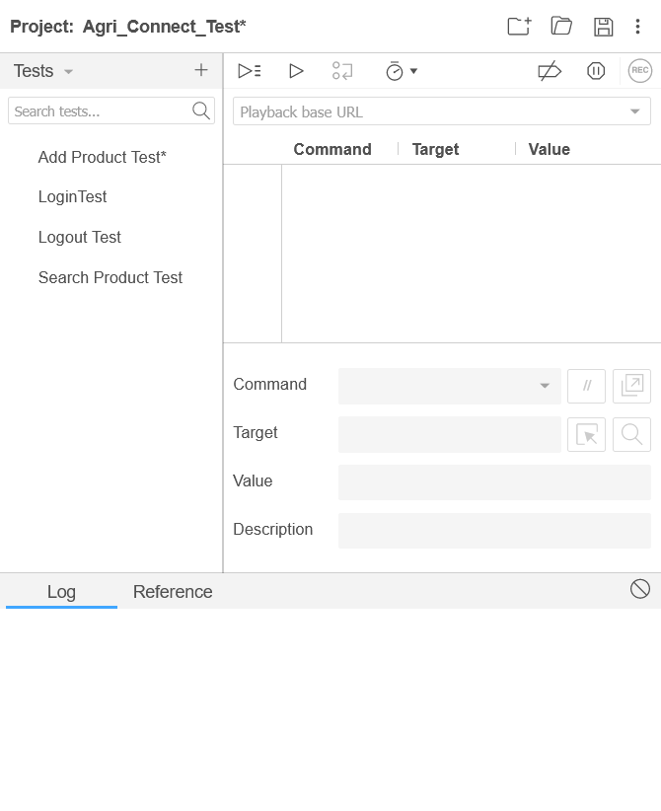

*Add all test names.

Step – 11.1 (Login Test)
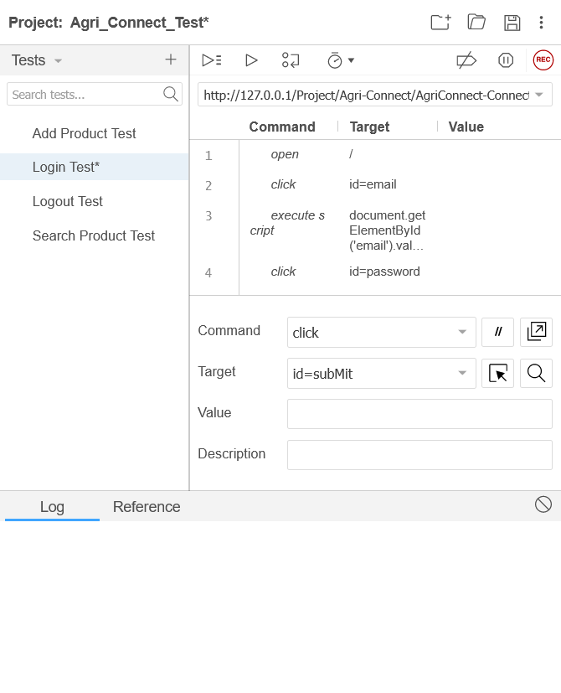
Commands input field
Commands

*In step 11.1 the command was provided to executing the test.
*In step 11.2 the Locating Strategies was collected for the testing command.

Step – 12
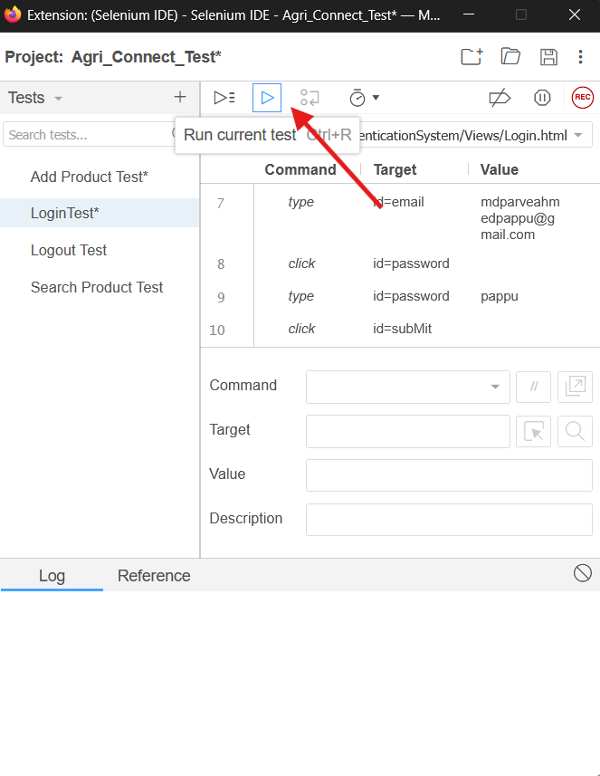

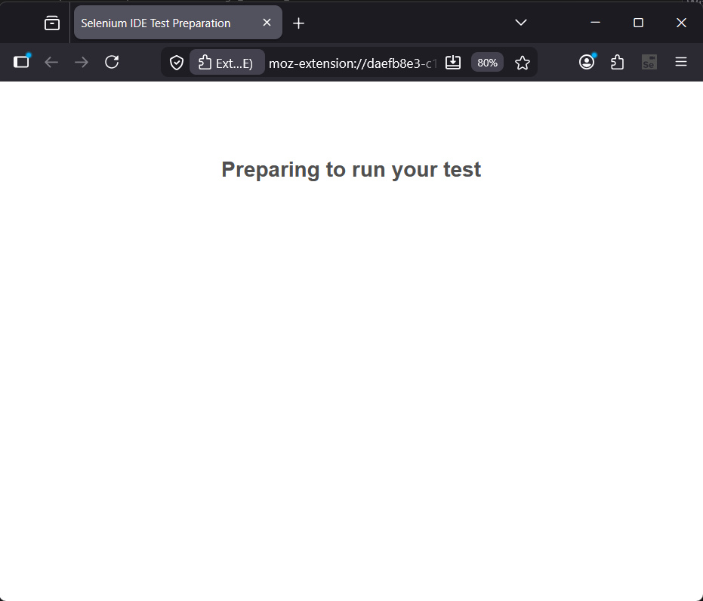
Step – 13
*After run the current test the test is preparing for the execution.

Step – 11.2
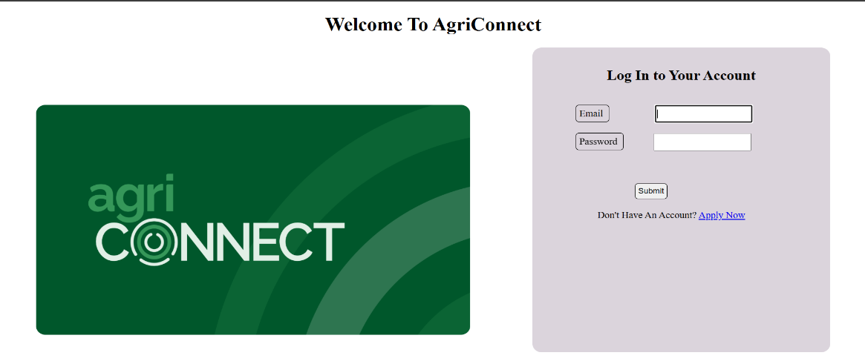
1. Project Interface for getting the Locating Strategies:
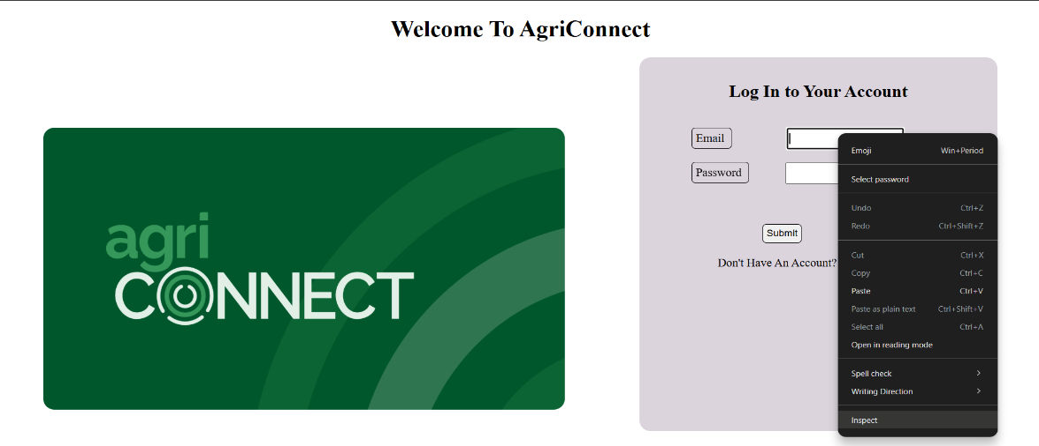
2. Click on Inspect
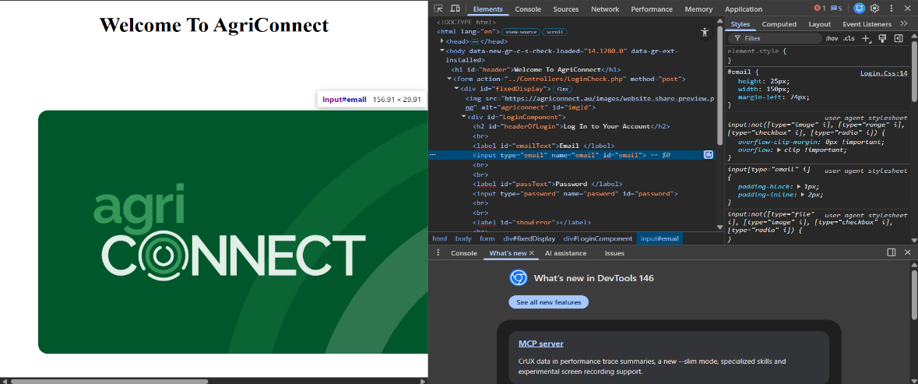
3. Get the id=email

Step – 14
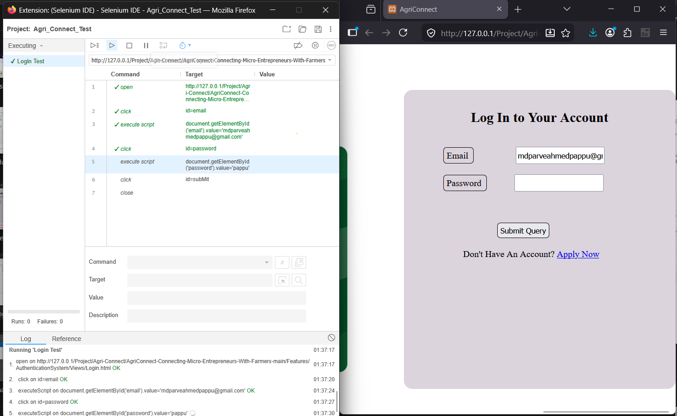

*Here the test is executing step by step according to the given command.
*1st the system opens the link, then click on the email field and the password field, After submitting the information the system will click on the submit button.
*When all test commands are successfully executed the system will close the window and the test will be completed with a successful message.

Step – 15
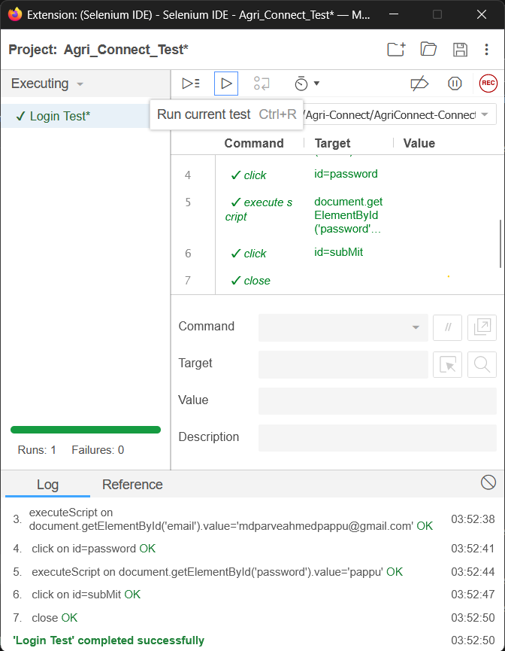
Save Button

*Here the Login test is completed successfully.
*Now to save the test the save button was used for this.
*Same procedure for the rest of the test execution.

Step – 16 (Search Product Test)
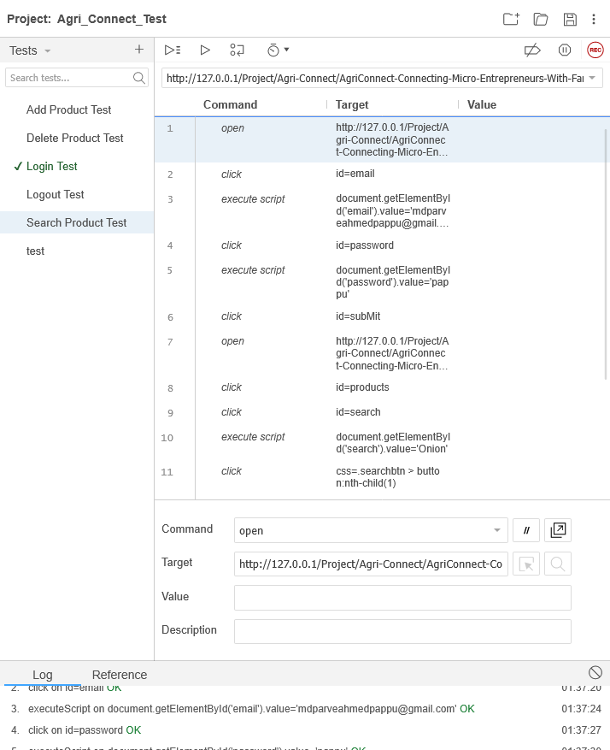

Step – 17
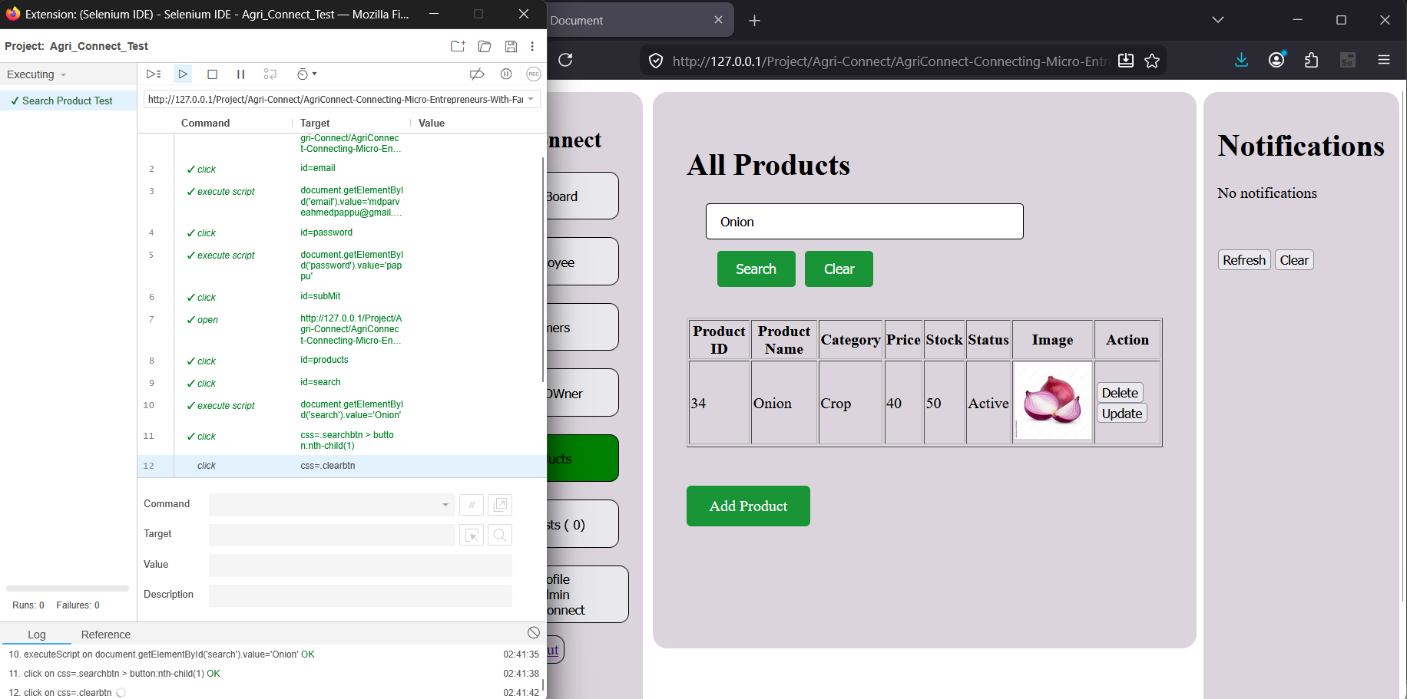
Search Product test execution
(search = Onion)

Step – 18 (Search Test successful)
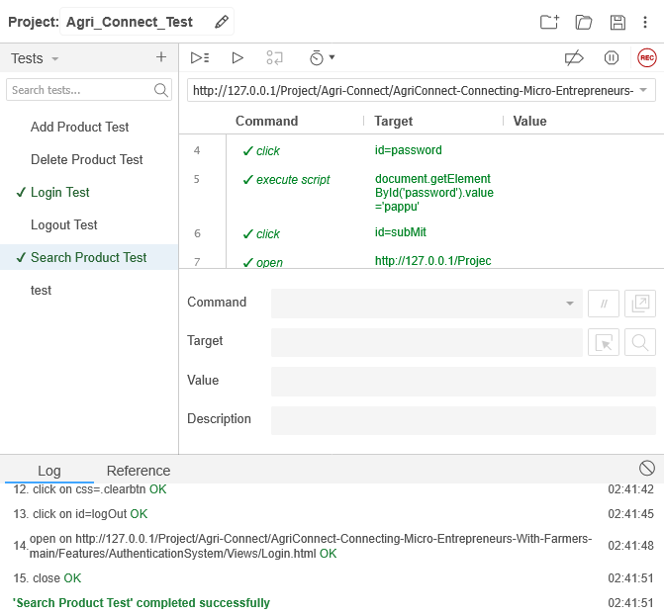

Step – 19 (Delete product test)
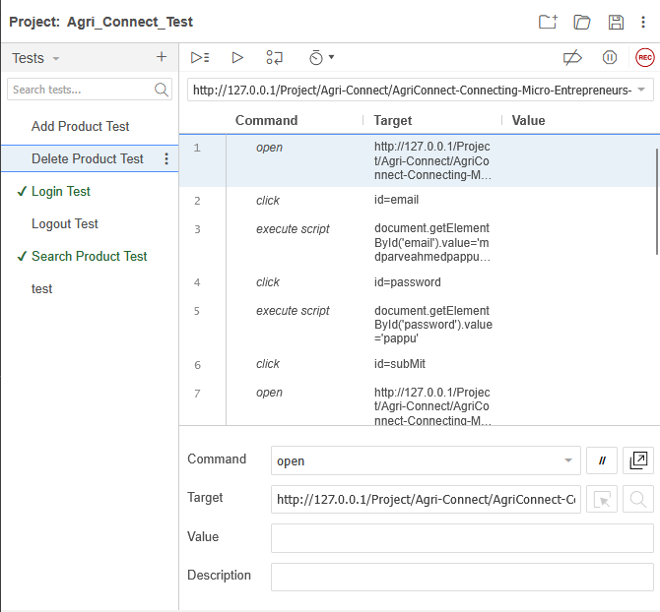

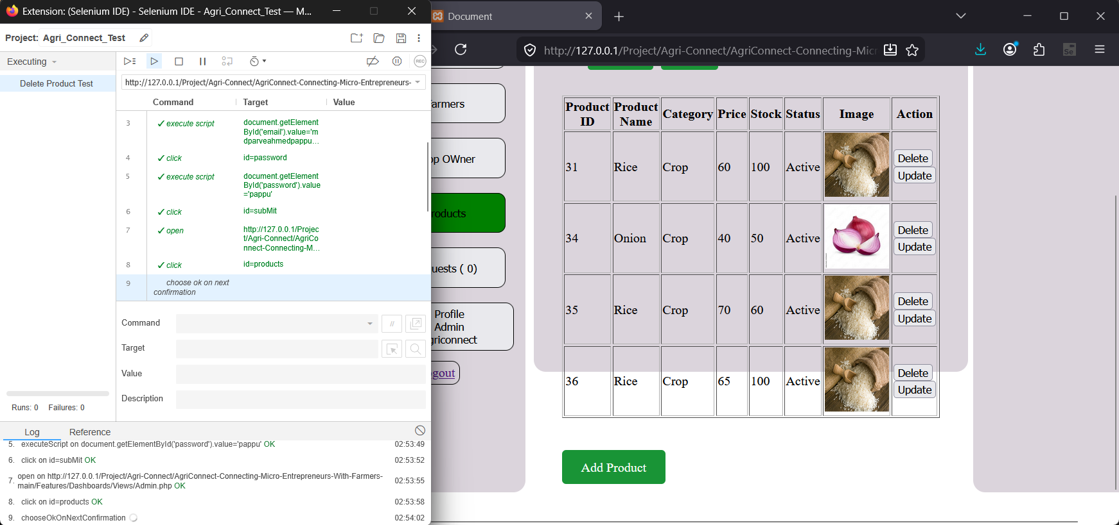
*Delete product test execution.
Step – 20

Step – 21
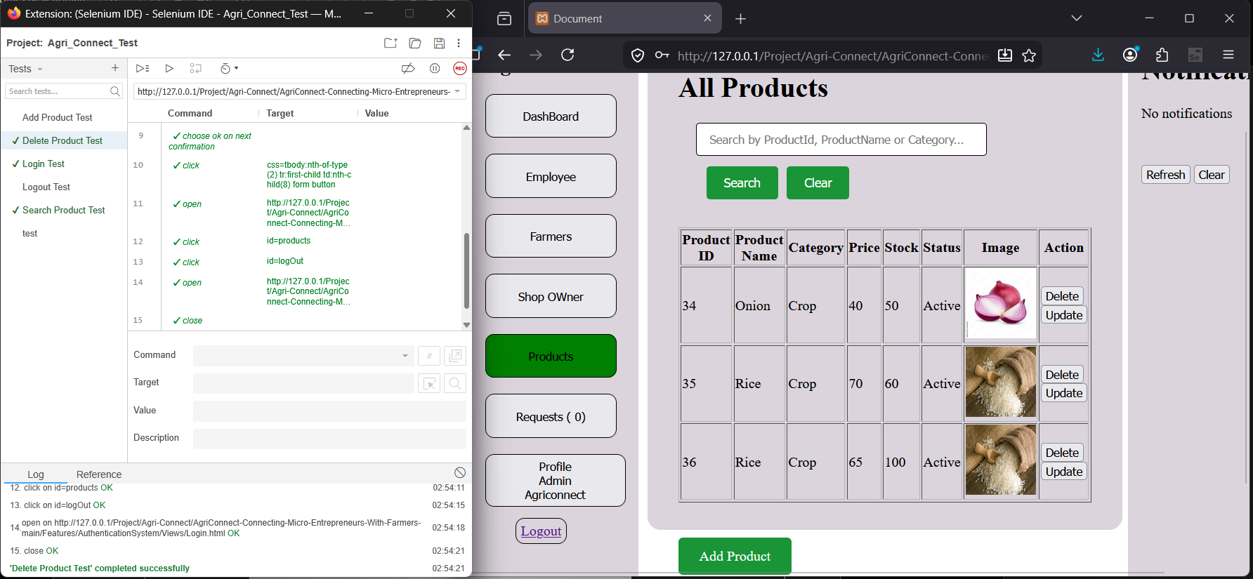
*Delete a product during the test execution.

Step – 22
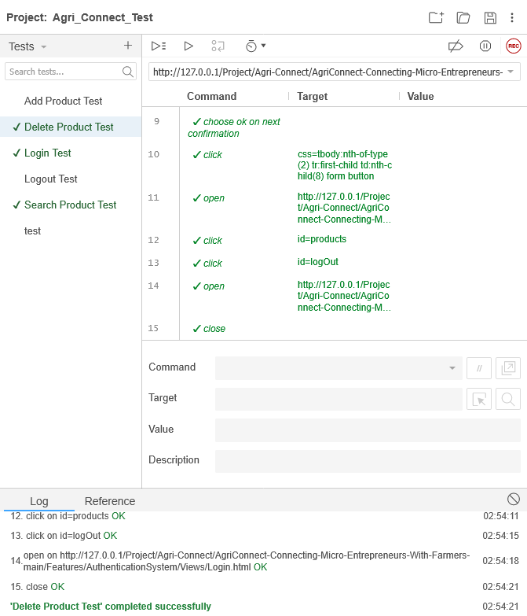

*Delete product test completed successfully.

Step – 23 (Logout Test)
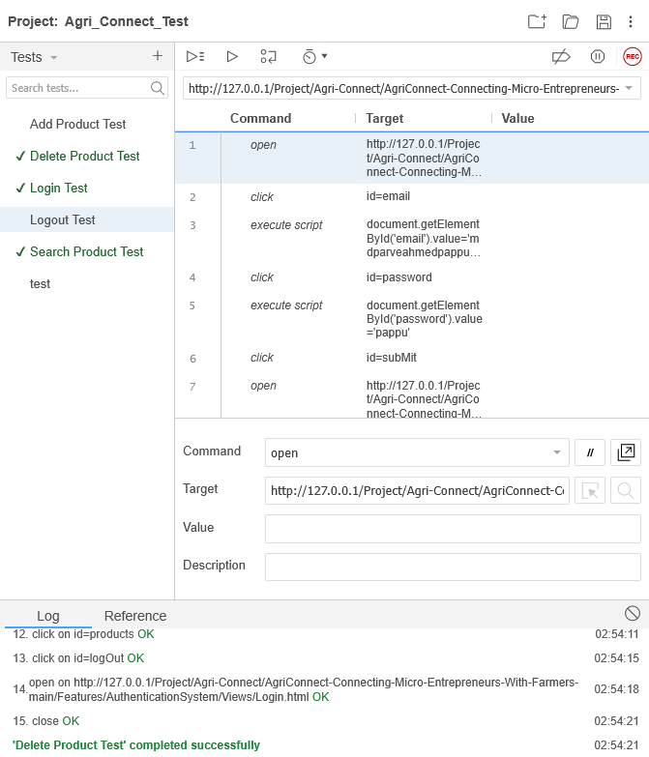

Step – 24
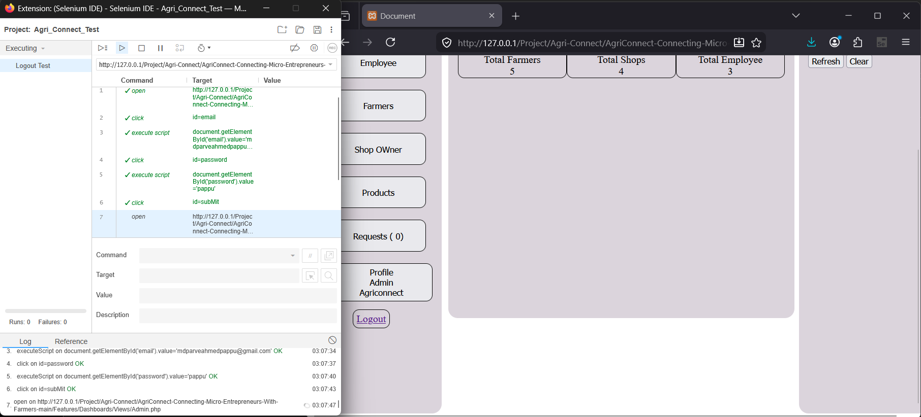
*Log Out test execution.

Step – 25
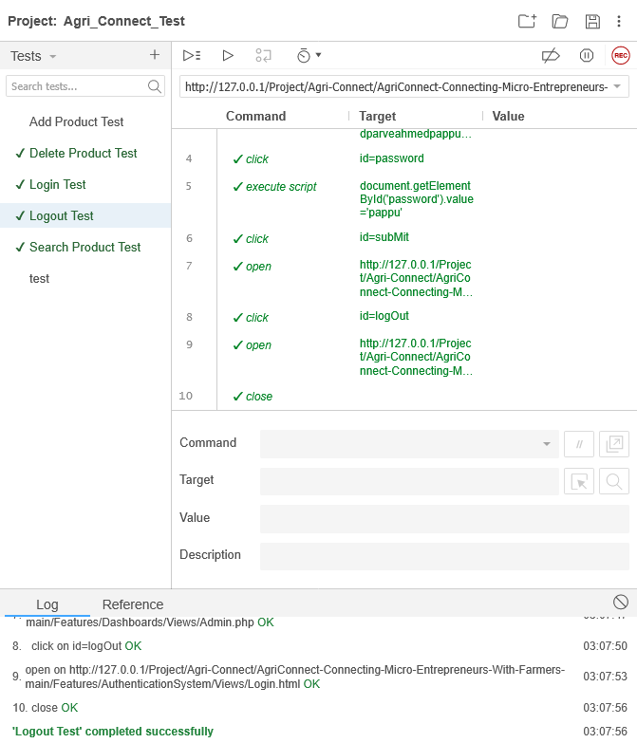
*Log out test completed successfully.

Step – 25
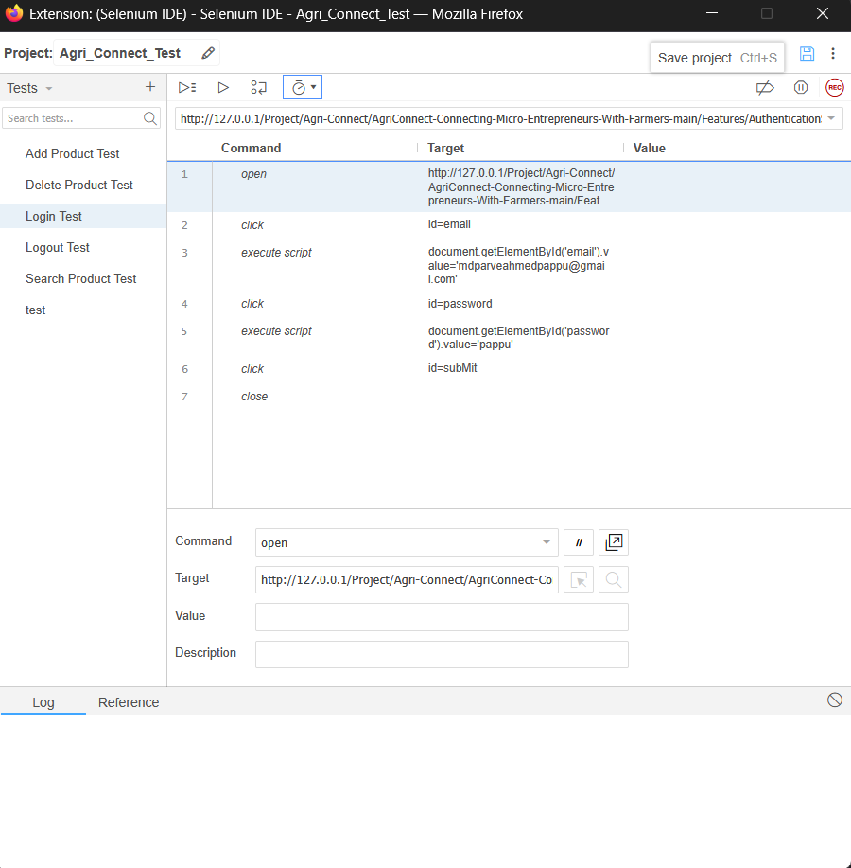
*Save project and the project will be saved on the specified location.

